**Assignment no-1**

1. Create a directory project_dir' & cd to 'project’.

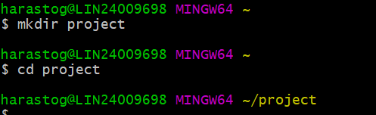

2. Initialize git version database. (git init)

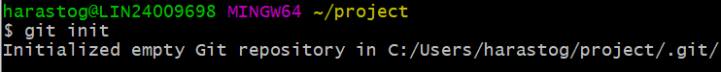

3. Create a new file index.html.



4. Check the git status. You should find index.html as untracked file.

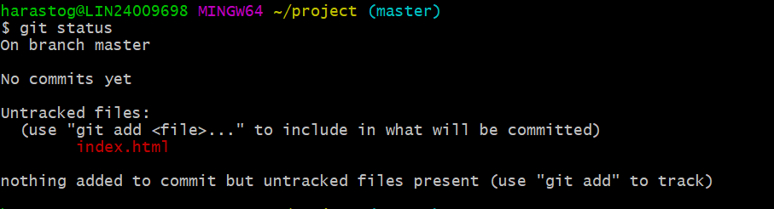

5. Stage the index.html file.



6.Commit the file

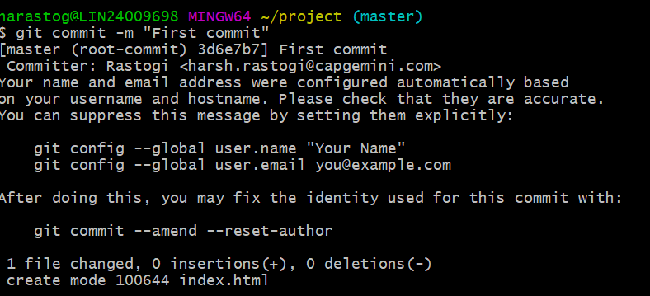

7.To see the logs of the file

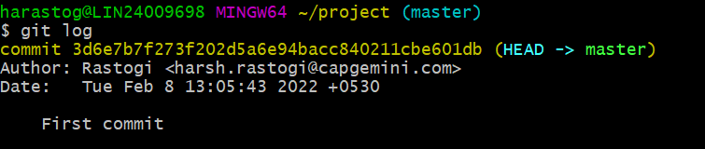

8. Make few changes in index.html & create a new file info.txt file.

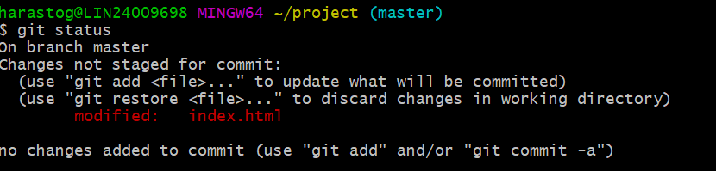

9. Configure GIT to ignore all txt files

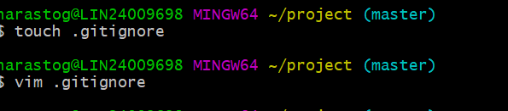

10. Again check the git status. You should find only index.html as untracked file.

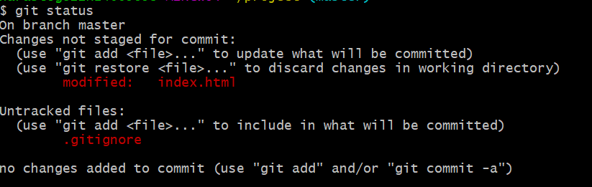

11. State & commit index.html

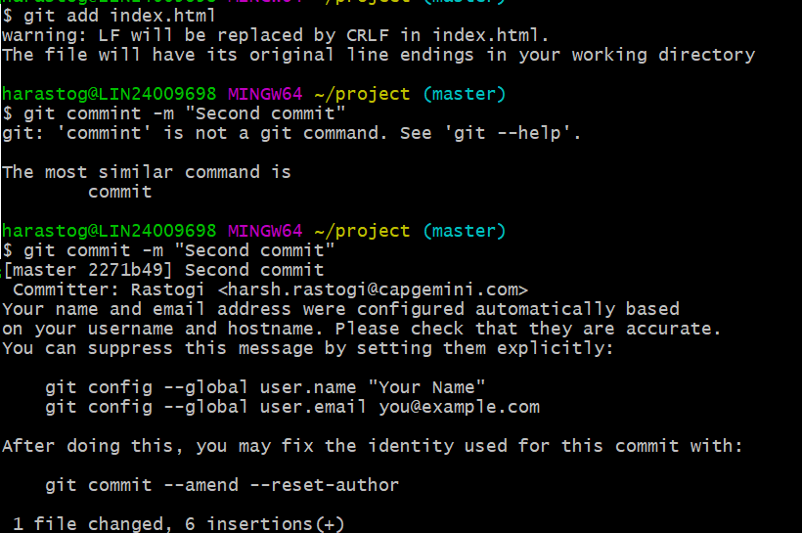

12. Log all your comments so far.

